Access Guide

Dunston Accessibility Centre

Accessibility

We hope that this document contains the access information you might need about attending the Gateshead System Changers: Exploring Accessibility event.

This guide does not stand in for asking what you need. We will contact you to ask about your specific access needs.

We look forward to welcoming you.

Getting to the venue
Dunston Activity Centre - Ellison Road, Dunston, Gateshead, NE11 9SS. The venue is also home to Dunston library so you may see that come up on Google Maps.

Public transport
There is a bus stop right outside the activity centre serviced by the following buses:
- 49 & 49A – Gateshead interchange to Winlaton bus station
- 96 – Gateshead interchange to Metro interchange
- X31 & X30 – Stanley bus station to Newcastle Eldon square

Dunston station is also near the activity centre on the Tyne Valley line with trains running between Newcastle and Hexham. To get to the Dunston Activity Centre from the station, head out of the station on to Ellison Street, then turn right. After around 1 minute the venue will be on your right.
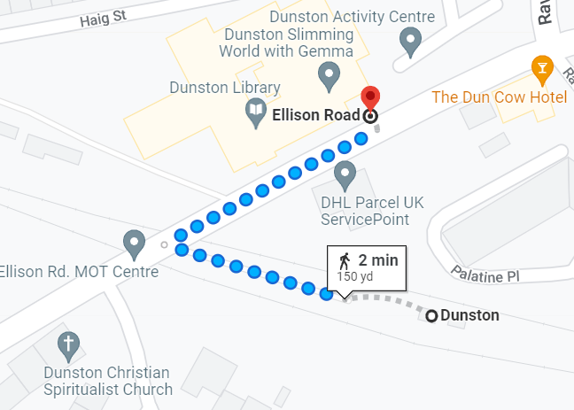

By car
There are many different routes to the activity centre. If coming from the A1, the easiest route is to come off the A1 at junction 69 onto the A184. Then take the first exit following signs for Team/Dunston/Metro Centre. Turn left onto Derwentwater Road (A1114), then at the roundabout take the second exit onto Ellison Road. Follow this road round the corner and turn right onto Ravensworth Road after the big Aldi. Then take the first left onto Haig Street and you’ll come around to the activity centre parking.

Parking
There is ample, free parking at Dunston Activity Centre either in their own car park or on the adjacent streets – Haig Street and Kent Avenue.

Getting in and moving around
The Dunston Activity Centre only has one floor. The Gateshead system changers event will take place in one of the community rooms towards to bottom of the building, but we will make sure the way to the room is signposted. There is a staffed reception at the entrance in case you need assistance. We will be seated around large round ‘cabaret’ style tables with plastic chairs. You are, of course, free to move around the space as you feel comfortable.

Entering the Venue
You will enter the venue through double automatic doors. There is both step free and stepped access to the doors situated either side of the vestibule. The whole centre is wheelchair accessible.

People using the venue at the same time as us
As the venue is a community centre, public library and gym, there will be other people using it at the same time as us. There are other meeting rooms in the building. However, as we are based in one room, there should not be much cross over with other centre users.

Facilities

Accessible Toilet
There is an accessible toilet close to the room. This is not a Changing Places toilet and does not have a hoist.

Fire Alarms
There are only visual fire alarms in all the hallways and public areas. Those running the workshop will make sure that all participants are aware of a fire alarm going off and make sure that they are evacuated safely from the building.

Catering for special diets
The caterers can accommodate a variety of dietary needs. We will speak with you individually about your dietary requests. Food will be simple sandwiches and crisps, all vegetarian.

Eating and Dining
We will serve food in the room the event is taking place in as part of a networking and working lunch. We will serve food as a buffet, but CIA or Difference NE staff will be able to assist you if needed. We note that this type of dining might make some people feel uncomfortable, especially with others that we might not know very well. You are welcome to eat wherever and however you like. We also aim to make everyone feel comfortable and welcome. You can contact Anya to talk about any element of dining and eating.

Gender Neutral Toilets
The accessible toilets at the venue are all-gender toilets. Otherwise, the toilets there are gendered as male/female.

Quieter Space
We only have access to one room with this booking where the event will take place. However, there is a small library space and a small communal seating area in the lobby which you can use if you need to find somewhere quieter to sit. It is important to remember that these spaces will be used by members of the public and so we cannot guarantee that they will be completely quiet at all times.

Contact information
You can contact Anya from Collective Impact Agency or Richard from Difference North East by email, text, or phone call. Please contact us ASAP to discuss any access information you need that we have missed.
anya@ciacic.com / 07595 941 848
Richard@differencenortheast.org.uk / 07498 317352

During the Event
We will check in with people during the event to find out whether you need any adjustments while we are there. We will then do our best to make them happen.

What to expect
The workshop is mostly discussion-based so that will involve talking to other people, sharing your ideas and coming up with new ideas together.
At times there will be people sharing back to a larger group, or one person talking to the group, but this won’t be for long periods of time.
There will also be some writing on large pieces of flipchart paper (and you might want to read what others have put too). But there will people from Difference North East and Collective Impact Agency to assist with this if that is helpful.

